Greetings from Millington,

CAPT Risley: Opening Remarks:

Good morning and welcome to the December OP Drumbeat TEAMS series. This month we have a presentation on the updates to the Supply Corps Officer Milestone and Command Qualification Program (NAVSUPINST 1412.1E) presented by CDR Matt Wall and LCDR Chad Brown. Thank you both for providing these updates on this important topic to the community. Matt and Chad over to you for the presentation.

Speakers: CDR Matt Wall and LCDR Chad Brown

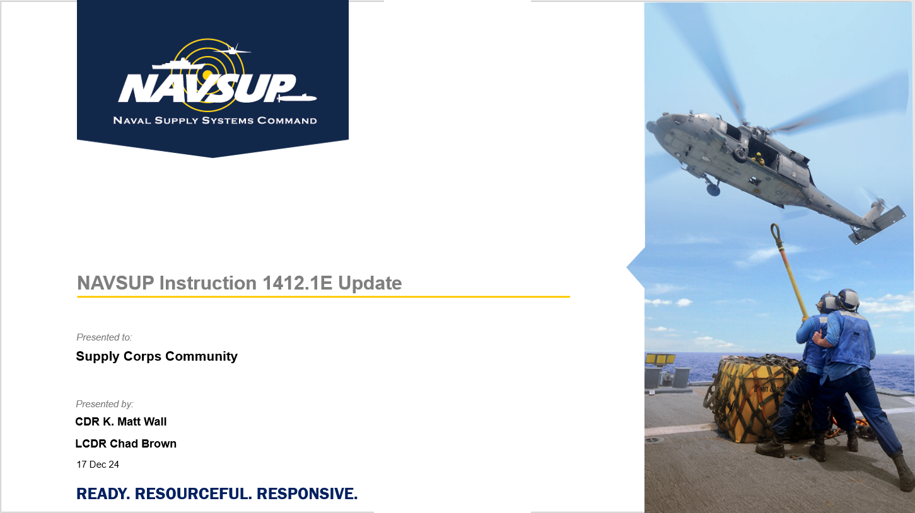

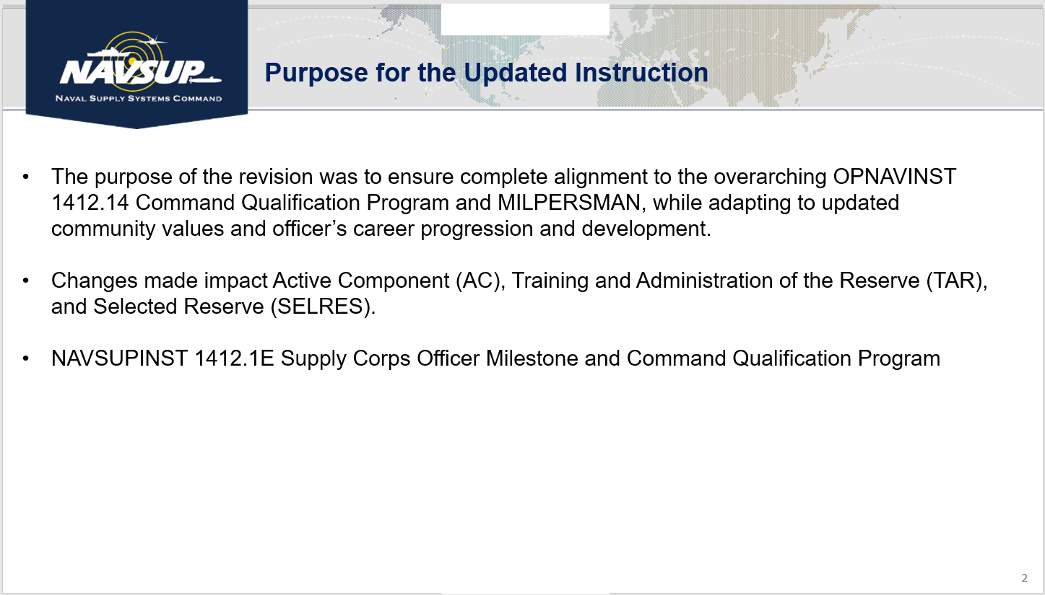

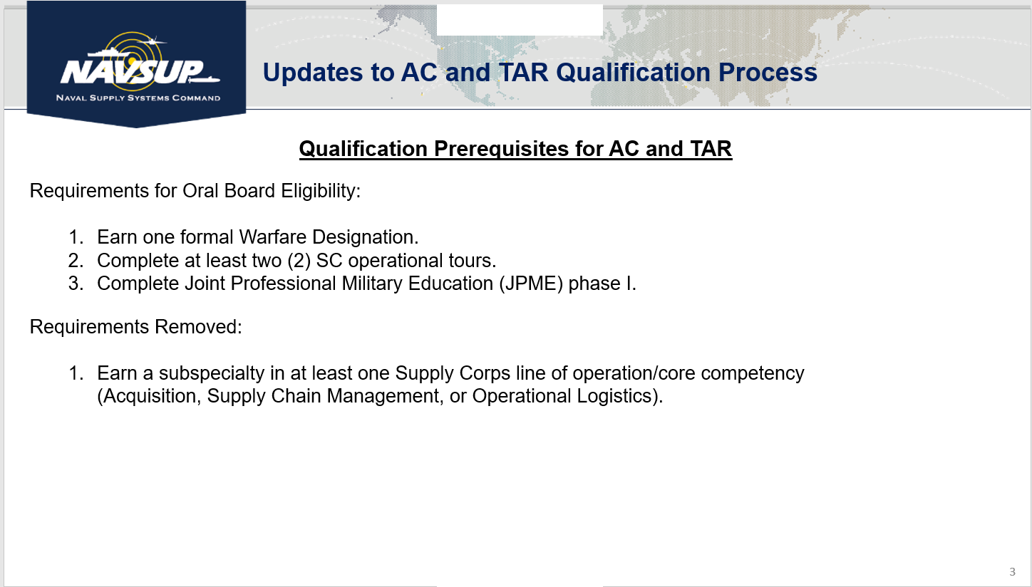

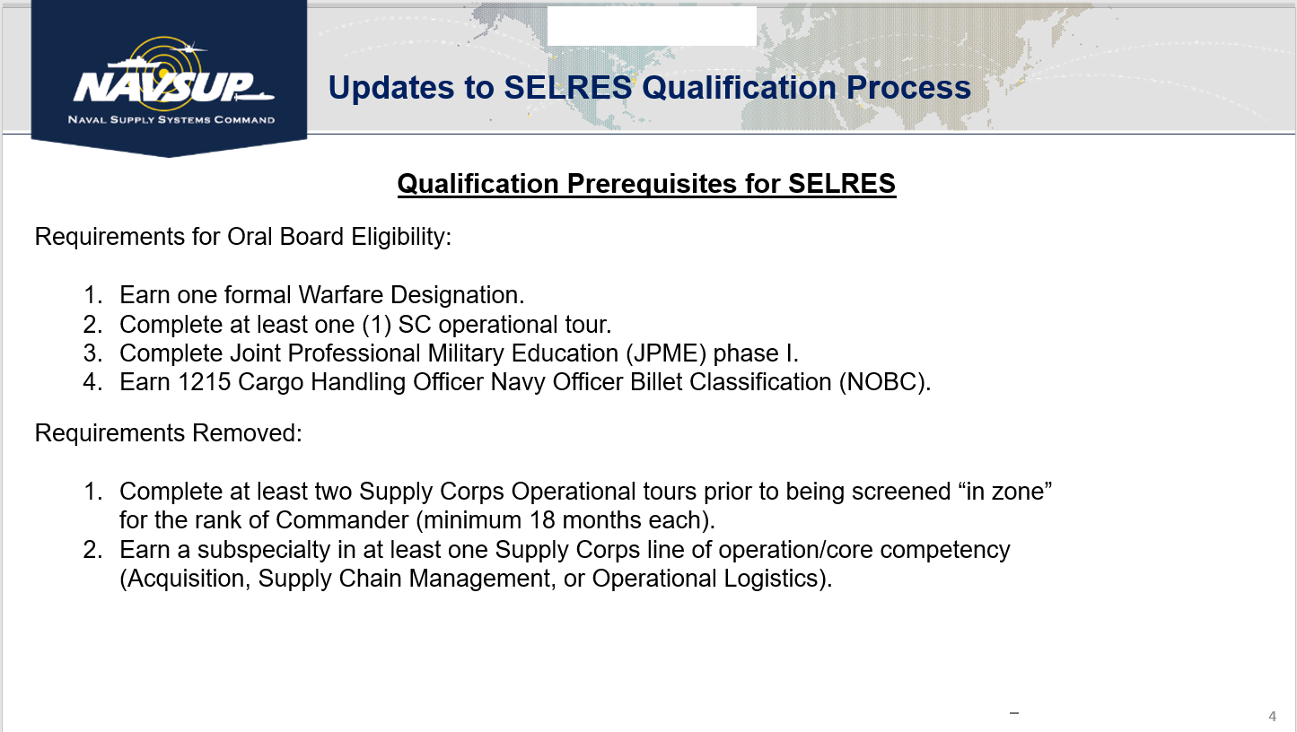

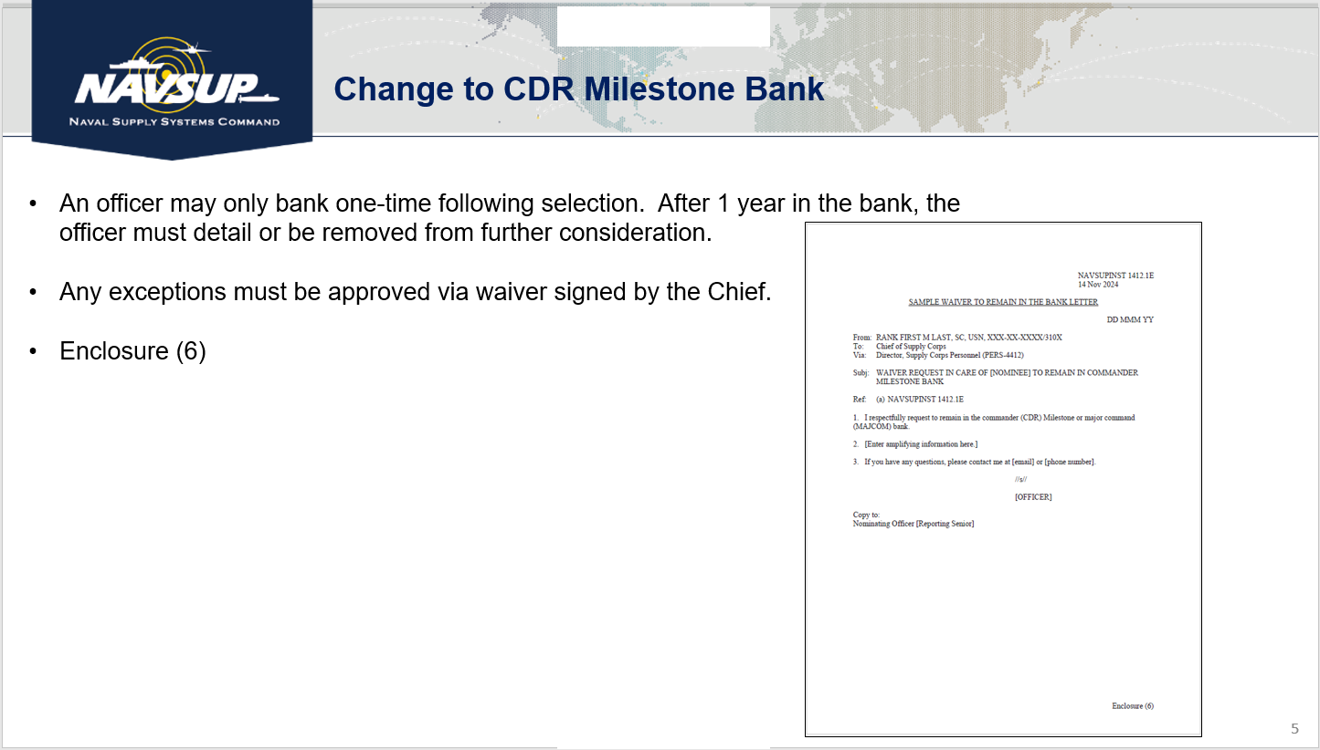

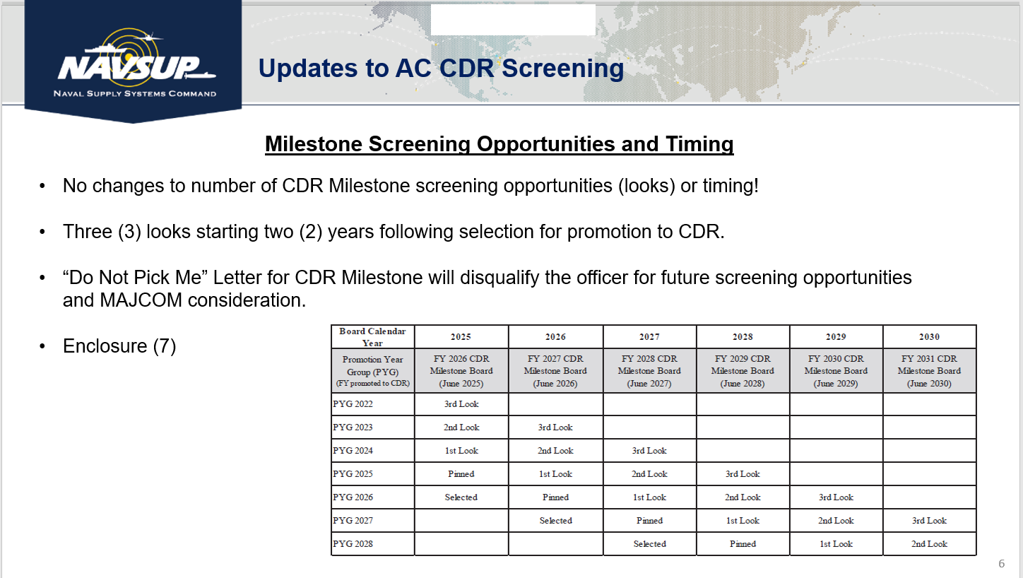

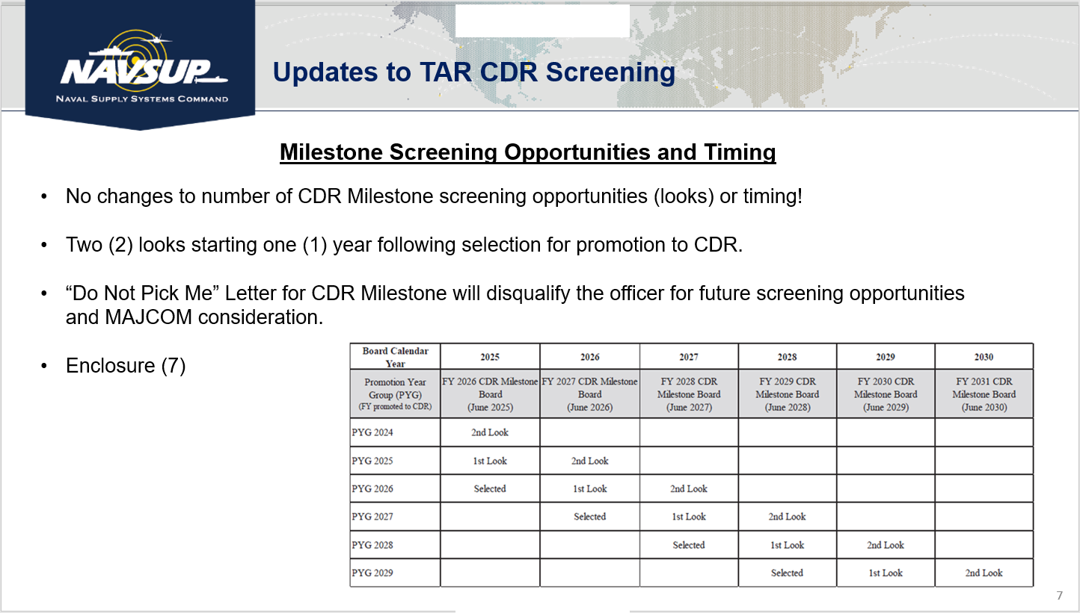

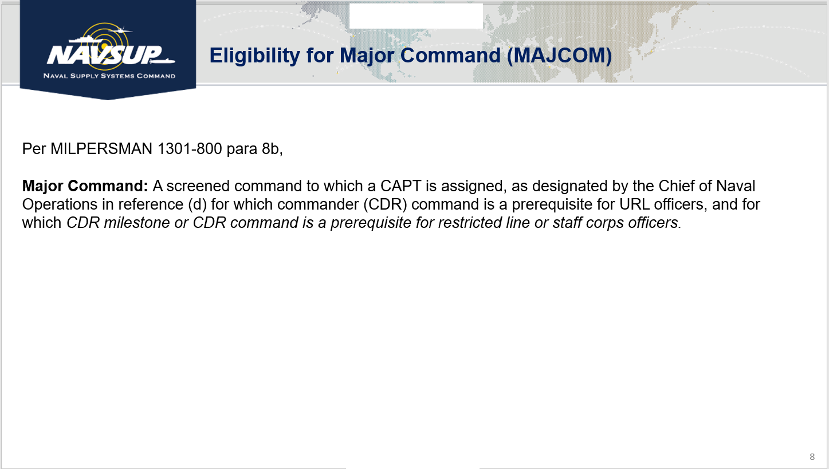

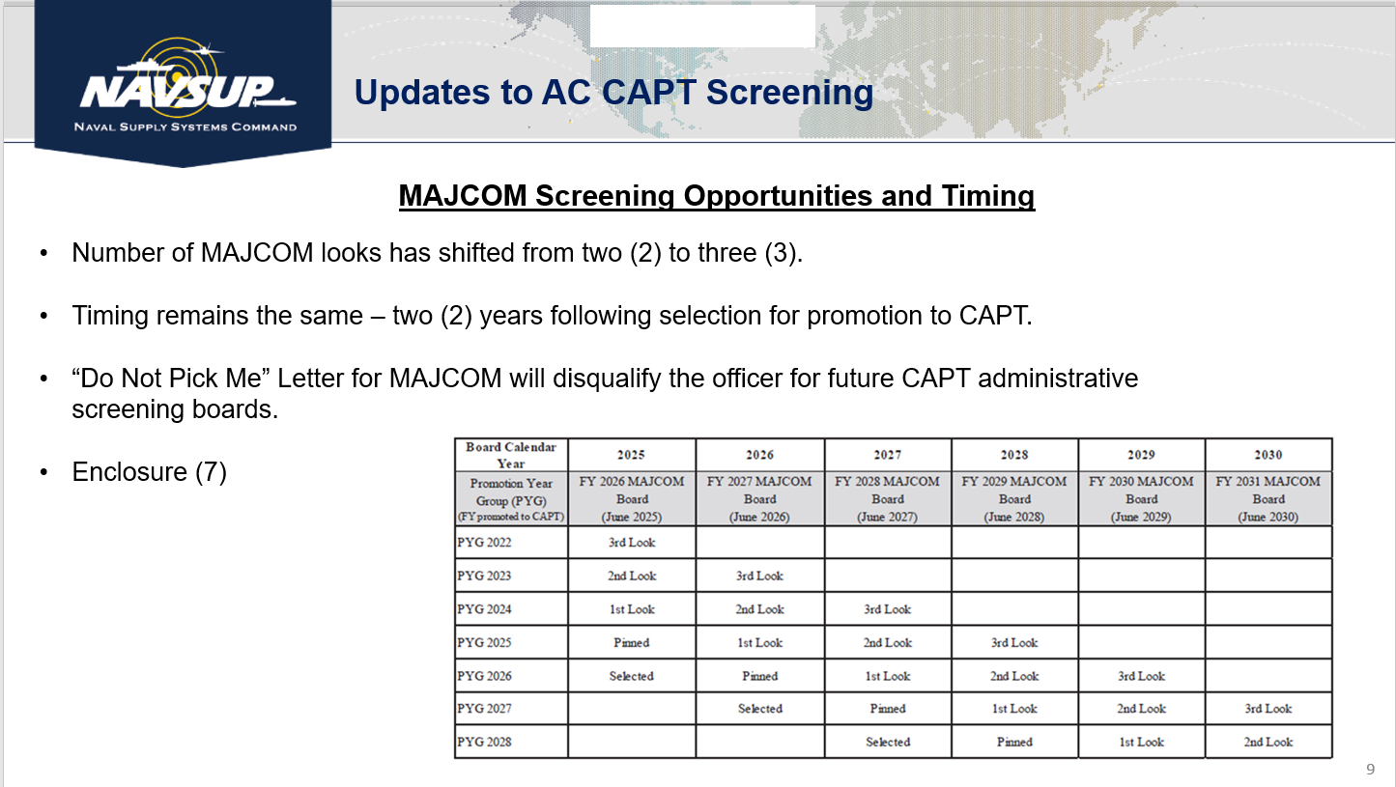

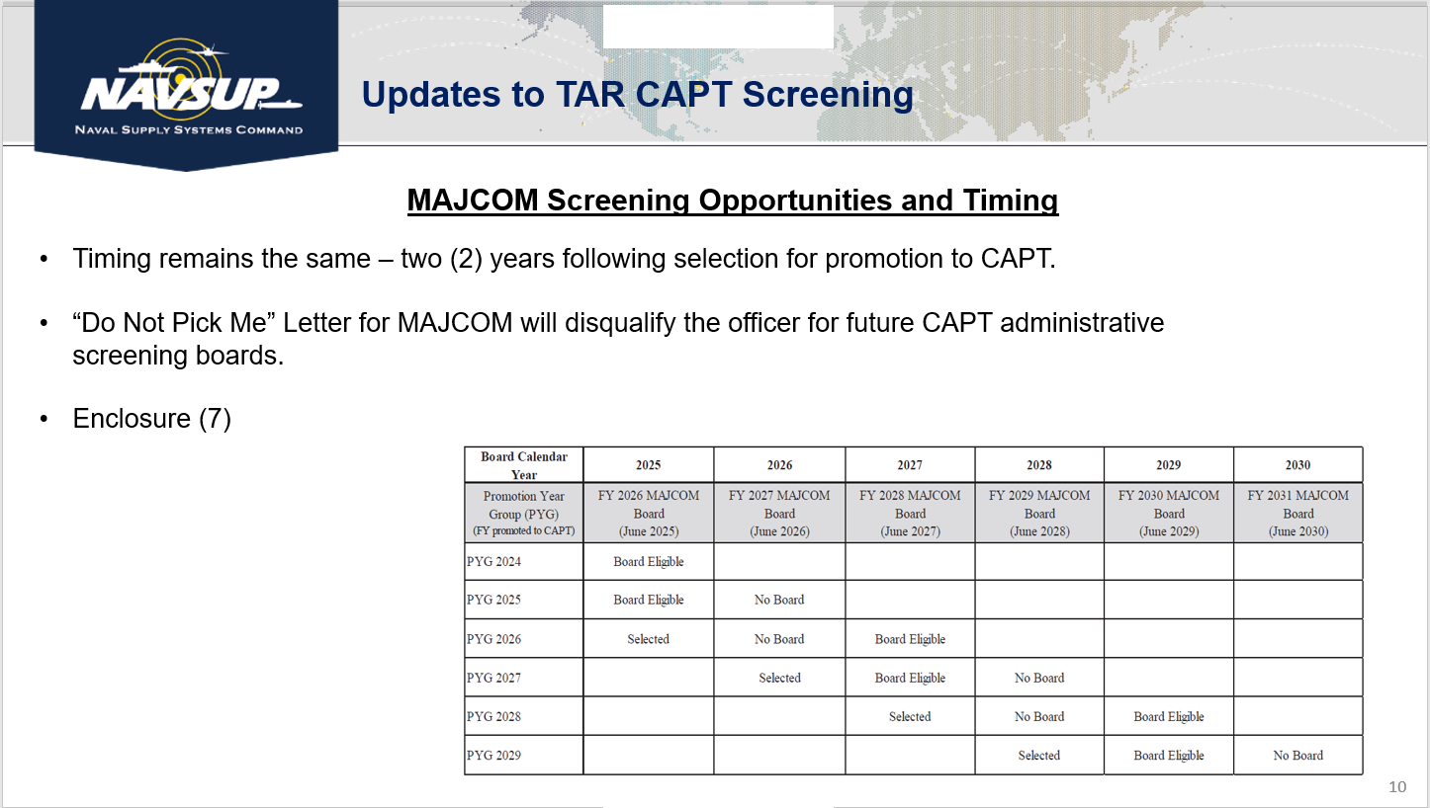

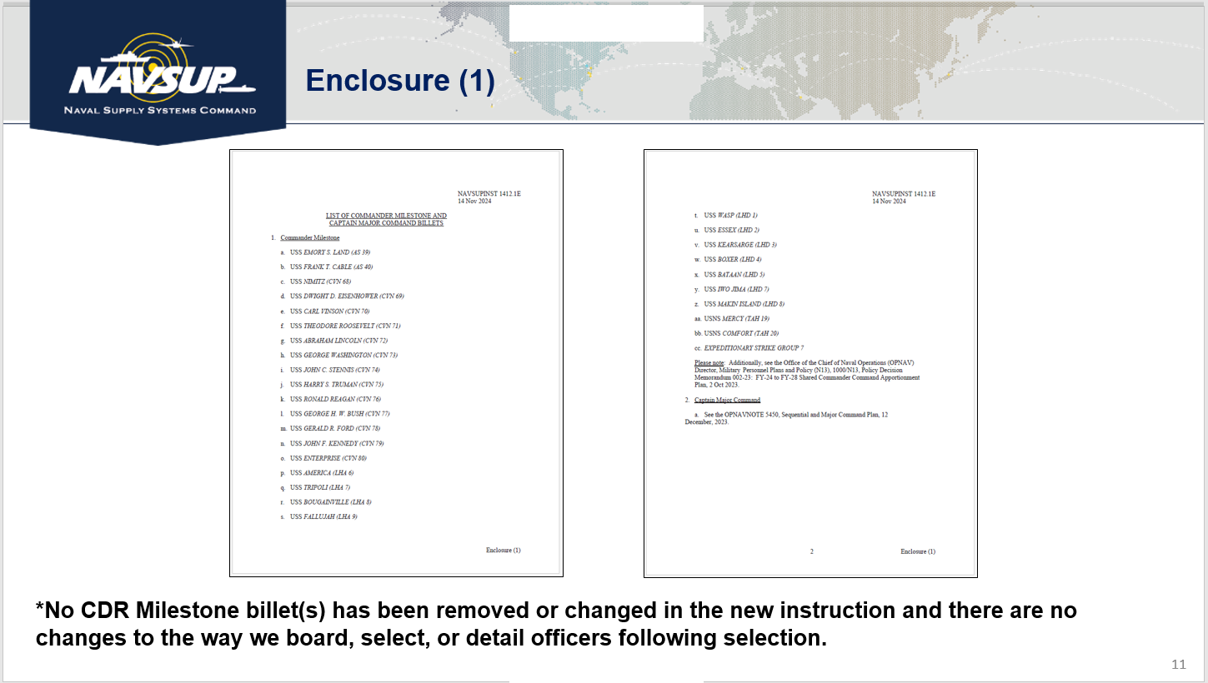



_____________________________________________________________________________________

CAPT Risley Remarks:

Oral 2D1 Boards: OP will be sending out an email in January with the process to schedule your 2D1 board and what to expect. Oral board season is from January to May and you’ll work with your local FLC coordinator to schedule those boards.

Milestone/MAJCOM Bank Process: While the new instruction does codify the bank process the process hasn’t change from our past practice. Currently you can bank for one year and if you need to bank again after that it’ll take an approved waiver from the Chief. Medical, situation with family, etc. are reason to request waiver from Chief. The only thing this instruction did for the bank was codify the process.

Milestone Looks: Milestone eligible officers will get 3 looks and is based on promotion year group. The 3 looks should be reviewed as: first look being similar to a below zone statutory board look, second look would be similar to an in-zone look, and third look would be similar to an above zone look. The majority of quotas for selection are in the middle promotion year group with the first and third promotion year group having less quotas.

Major Command Looks: Major command eligible officers will also have 3 looks, but instead of being promotion year group based its best player on the field.

Important Links:

[Supply Corps Officer Milestone and Command Qualification Program](https://www.mnp.navy.mil/documents/7769305/72925874408/NAVSUPINST%201412.1E_final%20for%20signaturev00.pdf/86185b38-b6cd-43bf-c208-5d321ab32e58?t=1732036699516)

_____________________________________________________________________________________

Q & A Session:

Q1. CAPT Walker: With removing the requirement for milestone eligible officers to have a Subspec how does this affect detailing to and after the milestone tour? The time between milestone and making CAPT is short so the officer may not have time to go get that specialty making it difficult to detail at the CAPT desk. Can any CAPT go into the specialty billets and do we believe the removal of this requirement will have impacts to detailing at the CAPT level?

A1. CAPT Risley: We took out the requirement from the instruction so that we better align with our community values and not because acquisition experience isn’t valued. While acquisition isn’t in our community values it is in merit reorder. With the O4 operational tour becoming more likely for current and future O4s we may see where these officers are getting that acquisition experience at the O5 level instead of before the O5 statutory board. There are however still milestone tours in contracting that ideally we’d send a qualified contracting specialist to. We list a target selection goal in the CDR Milestone Convening Order, but the board selects the best and fully qualified records and may not meet the prescribed goal. This year we had to send an officer to a contracting MAJCOM billet who wasn’t a contracting qualified but was an acquisition corps member. For both milestone and MAJCOM we are looking for strong well-rounded leaders not necessarily skill set specific.

Q2. LCDR Morlan: Is it correct that for milestone there are actual quotes for each YG (first look, second look, third look)?

A2. CAPT Risley: There are quotas we determine them based on: number of billets rolling, how many are in the bank and the how many we want to maintain in the bank, and health/opportunity rate for each PYG. We like to keep the opportunity around 40-60% for each year group. The first and third look year groups will have less quotas then the second look year group.

Q3. Chat Question: Are CVN 80 Enterprise and LHA 9 Fallluja going to be on the slate for CY26?

A3. CDR Wall: We currently have them listed in enclosure 1 of the instruction, but when they appear on the slate will be determined by the delivery of the ship.

Q4. CAPT Bolls: At SCSLS you talk a good bit about declination and why that is important. Matt covered the “Do Not Pick Me” letters, but can you elaborate on declination?

A4. CAPT Risley: Let’s elaborate on the difference between DNP letters and declination:

Do not pick me letters – Officer is eligible but for some reason has asked to not be screened by the board. The officer submits the letter before the board and their record is pulled from consideration. There is no adverse impact to the officer’s record.

Declination – Officer is screened and selected for milestone or MAJCOM, but declines the assignment (medical, didn’t like the detail process, etc.) to go to their milestone/MAJCOM tour. A declination results in a field code 17 (FC-17) and will become a permanent part of an officer’s record. We want to avoid declinations due to someone not happy with the detail. We try to match the officer with one of their top 3 preferences, but it doesn’t always work out that way.

If you are selected for Milestone/MAJCOM we need you to be ready to serve when and where needed.

Q5. CDR Ileto: Based off the new instruction an officer is no longer eligible for MAJCOM if they haven’t completed a milestone tour. How does this effect Captain Command and how are the Captain Command billets determined?

A5. RADM Epps (Chief): We haven’t published that distinction yet. We are waiting on the BUPERS Major Command Review Board process. Once that happens I’ll send a note to the entire community on what is going to be shared.

Q6. Chat Question: Are there efforts to balance the Commander Milestone Billets?

A6. CAPT Risley: Before we can rebalance we have to get TYCOM approvals. We have made an effort and strides in the past to rebalance, but will continue to partner with the TYCOMs on potential future opportunities.

Q7. LCDR Meyer: Is there a distinction between the Milestone Board selection promotion year group quotas compared to the milestone assignments? Is there a quota for assignments versus the actual milestone board process?

A7. CAPT Risley: I think in a way you’re asking how do we determine who stays in the bank and this is based off a number of factors. Is someone joint locked, do they have a personal situation, or did they recently execute a PCS move and need to stay put for a bit longer. All these factors are taken into consideration when detailing/banking an officer for milestone. Now there have been instance where an officer immediately goes to milestone potentially due to seniority if selected on their third look, but it’s a case by case basis.